Design elements principles

Though design can be fun and exciting, working with design elements and principles can be intricate and complicated. In this reading, you will explore design elements and principles to gain a deeper understanding of their usage.

**Lines**

Lines are any linear marks, so if you think about it, lines include nearly everything. They even include the words and letters you are reading that consist of thousands of curved, angled and straight lines. Lines can also guide specific ideas. For example, straight lines can convey order and neatness, wavy lines can convey movement, and zig-zagged lines can convey tension or excitement. The use of 'leading lines is a common technique in photography. Finding and emphasizing strong leading lines in your piece can help direct the viewer's attention through the entire article or specific areas.

**Scale**

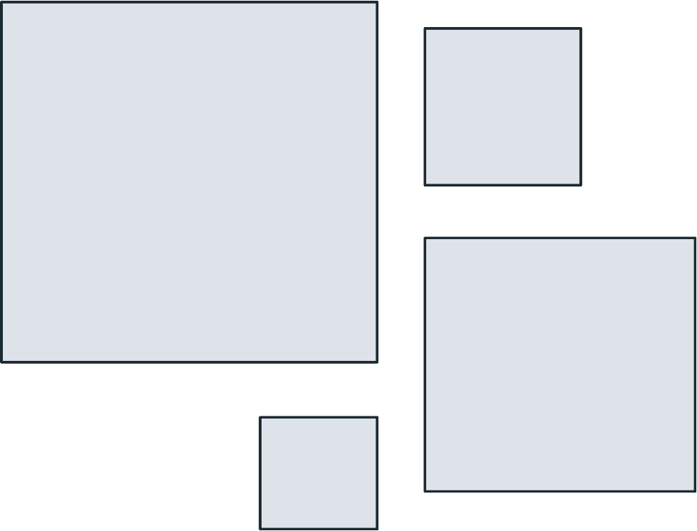

Scale plays an important role in the design, sometimes literally. Scale is the deliberate sizing of individual elements in their most basic form. Scale can help you make sense of designs and images. However, the scale does not always have to be realistic. To create stunning effects and signal which parts of your design are more important and less important. You can size your elements dramatically, large or small.

**Color**

Color is essential in design. Color creates moods, atmospheres and emotions. Each shade also has its own connotations. Color, in short, can make or break your design.

**Repetition**

Think of any well-known brand. I'm sure you can all recall their logo, general tone of voice and general color schemes. Why are these things so memorable? You guessed it: repetition!

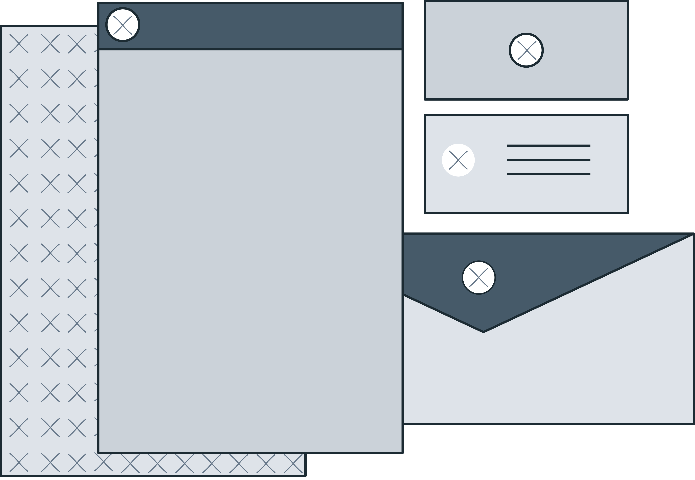

When it comes to branding design, repetition is essential in keeping your branding consistent and tying your items together.

**Negative space**

Negative space is the "space in between," or the area between or around other elements that form its own shape.

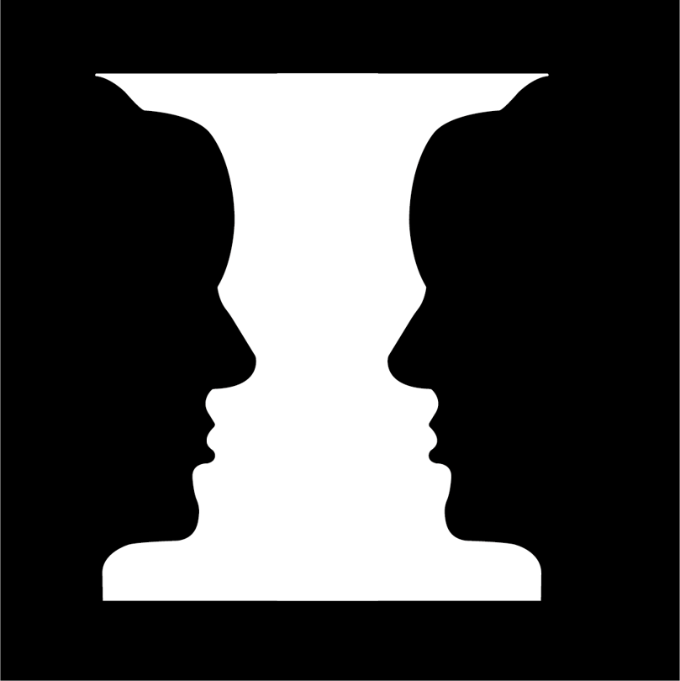

When used strategically and cleverly, negative space can help create truly stunning and clever designs.

**Symmetry**

It has been scientifically proven that humans are drawn to symmetry. We find symmetrical faces, patterns and designs more appealing, effective and beautiful. Symmetry is not always an option for every design. Instead of attempting to achieve perfect symmetry, try to introduce subtle elements of symmetry into your design. Using symmetry, you can create a sense of balance and order in a layout.

**Transparency**

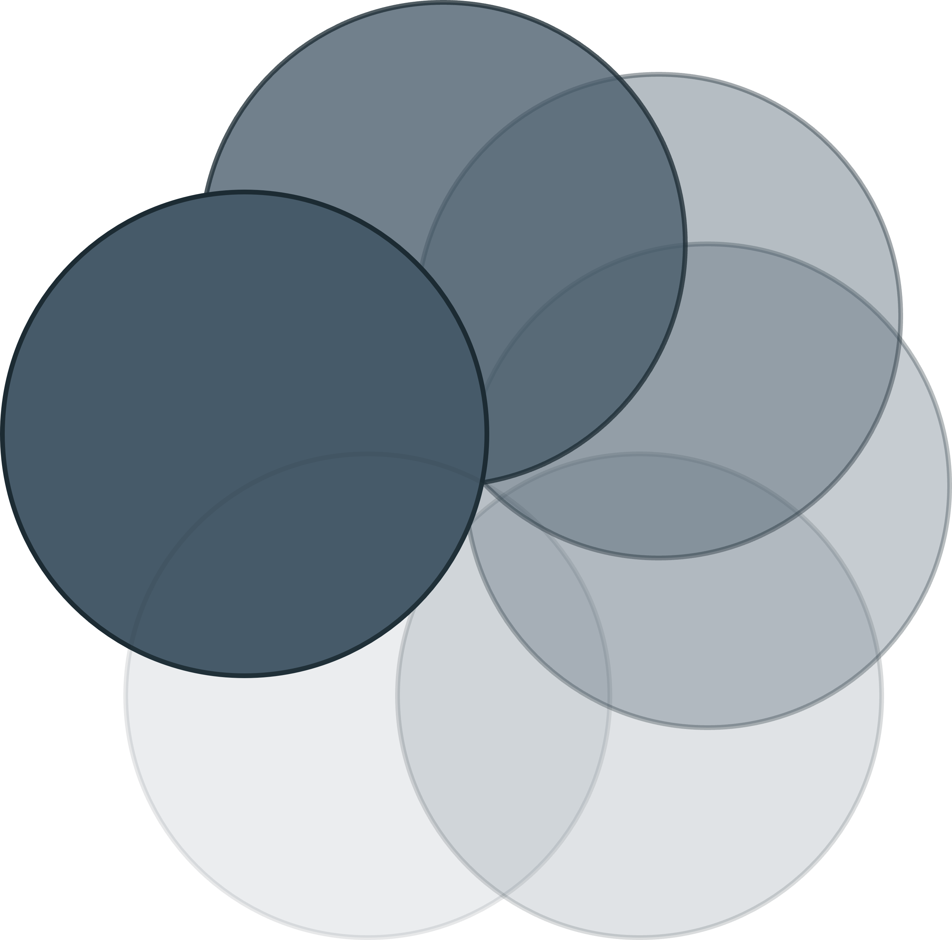

Transparency, also known as "opacity," refers to how" see-through" an element is. The lower the opacity, the lighter and less noticeable the element, and the higher the opacity, the more solid the element.

**Texture**

Texture can add tactility, depth and cool effects to your design.

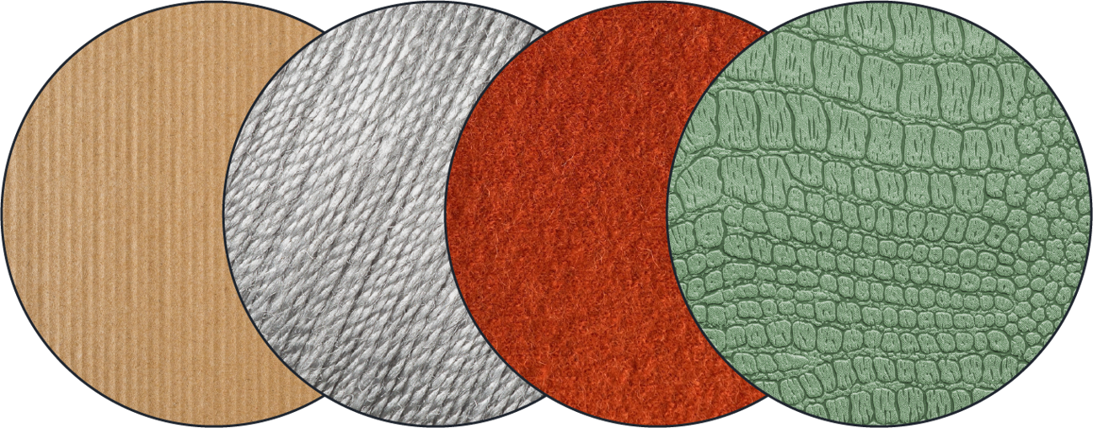

You can create a distinctive piece for your design that will stand out from the crowd by considering texture and how your design literally and tangibly feels.

**Balance**

Balance ensures that no element overpowers another.

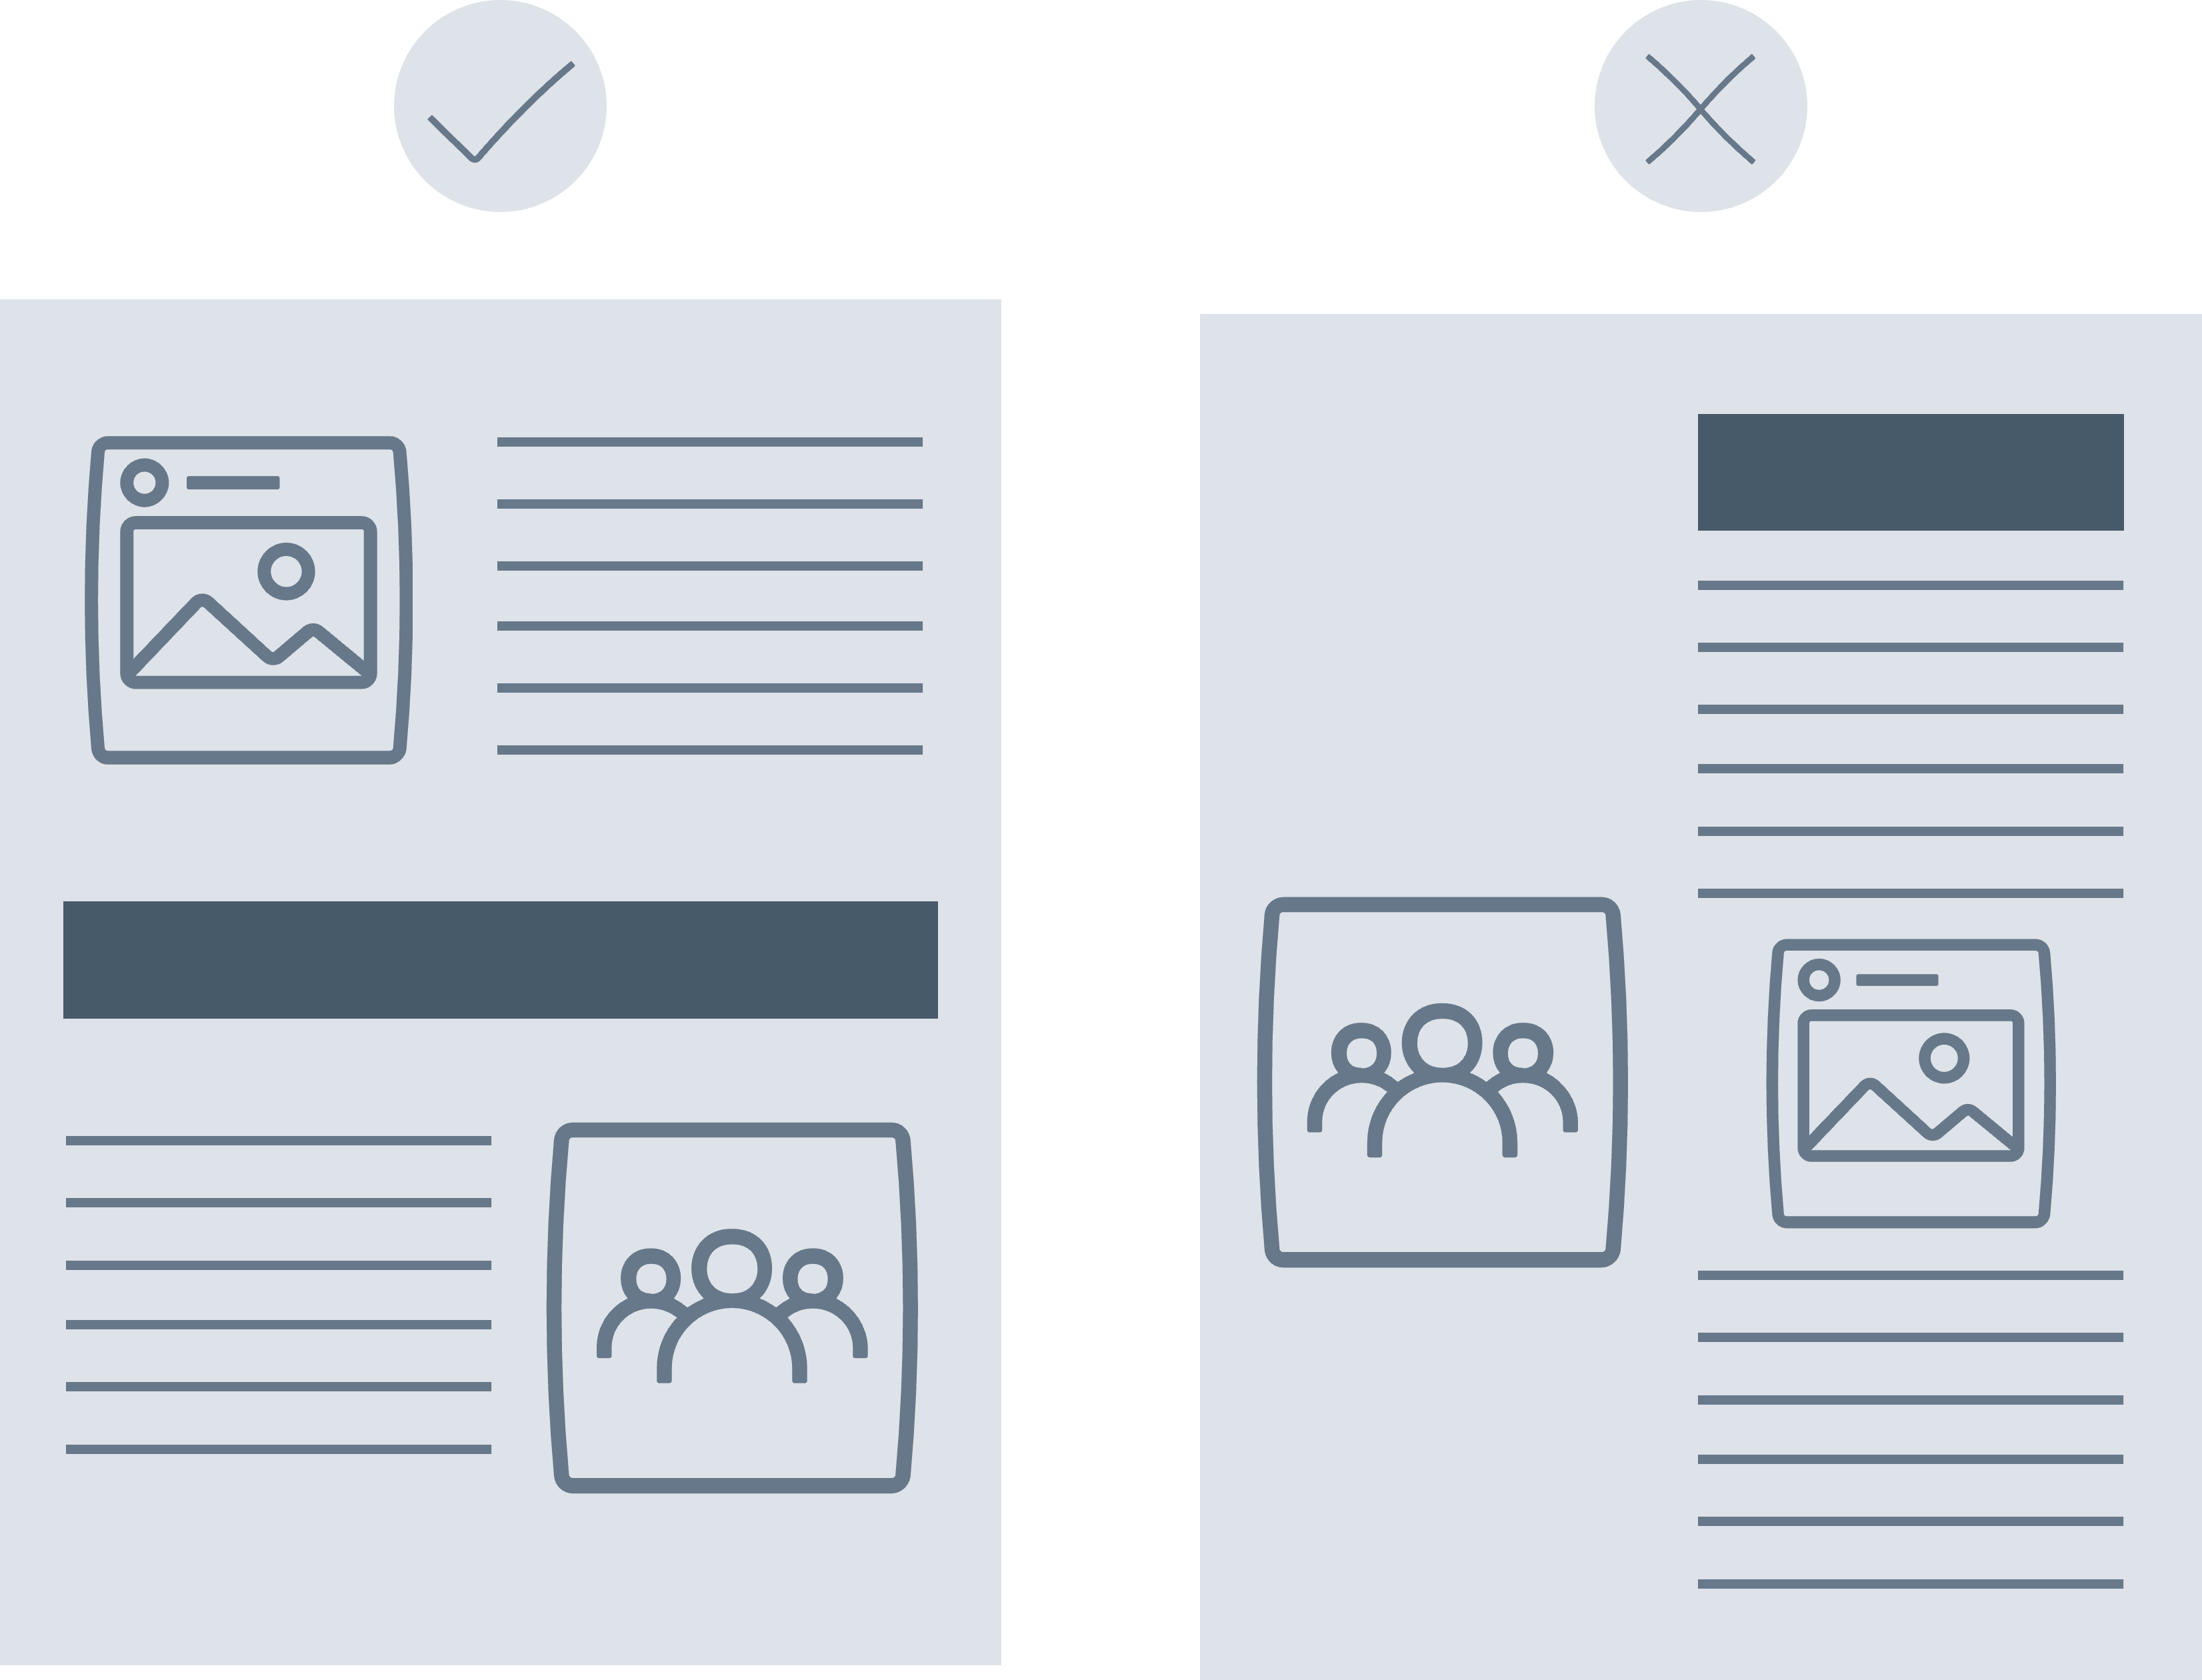

One technique for mastering balance is to imagine each element as having a 'weight' behind it. Consider each element's size, shape and 'weight' in relation to other elements on the page, from text boxes, to images, to color blocks.

**Hierarchy**

The most important things on your page are headings and titles. These are at the top of a hierarchical scale, and they command the most attention. Next, we have sub-headings, pull quotes, and additional information. A pull quote is a small section of text extracted from an article or book and quoted in a different format. Make sure these are eye-catching and noticeable but not as prominent as your headings. Elements of your design that are given the least amount of visual charm are things like body copy, less important information, links and so on. Hierarchy does not stop with type. Images have a hierarchy as well. The elements of your image that are larger, more colorful or more central will have a higher hierarchy than those that are smaller, duller or less detailed.

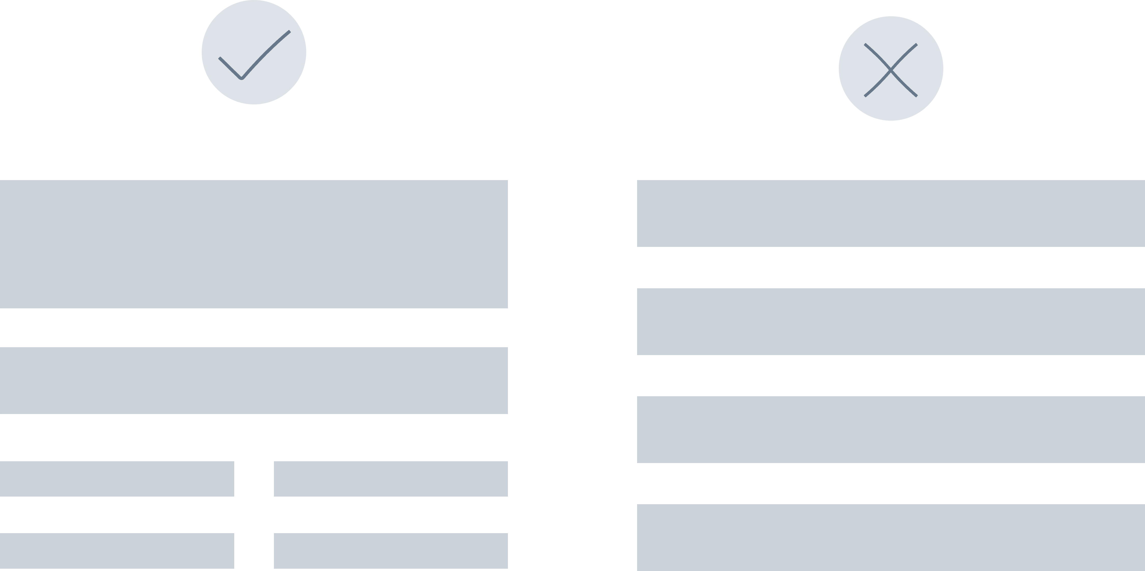

**Contrast**

Contrast is frequently the magical, key ingredient in making your designs "pop" or stand out.

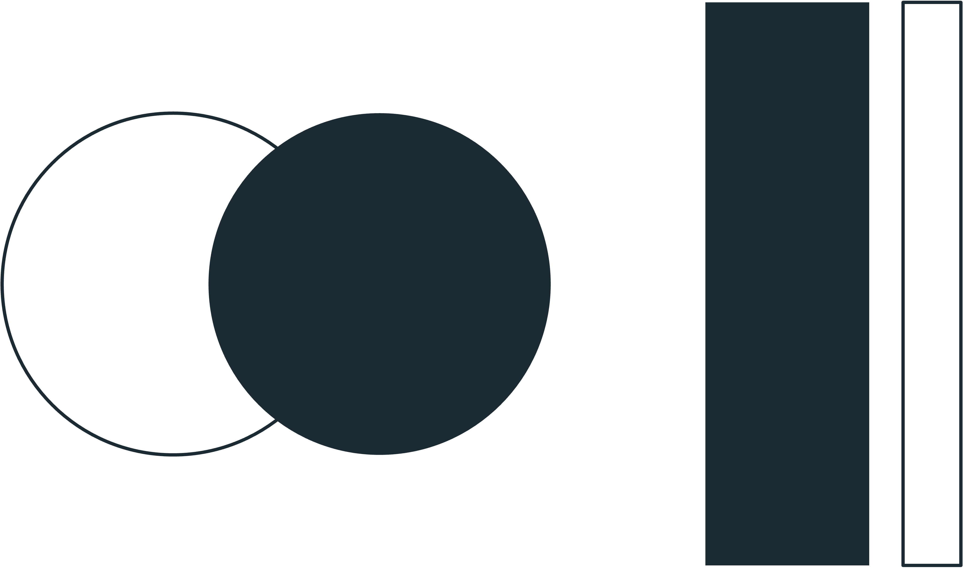

Contrast, in its most basic form, is the degree of difference between two elements of your design. Dark versus light, thick versus thin, large versus small and so on are all examples of contrast. Contrast has a significant impact on readability and legibility. Contrast is more than just a stylistic element or a legibility enhancer; it can also be used to draw attention to specific elements of your design. Designers use this technique often in website design. So, use contrast to make your designs visually 'pop" or stand out, drawing attention to specific design elements such as "call-to-action" buttons, which are instructions given to the visitor to entice them to take action. A "call-to-action" button could be as simple as "call us now," "find out more," or "subscribe to our newsletter."

**Frame**

Correctly framing your designs is just as important as framing your photographs and works of art. Think of framing in terms of photography - what you include, exclude and so on. However, framing is just as necessary in design.

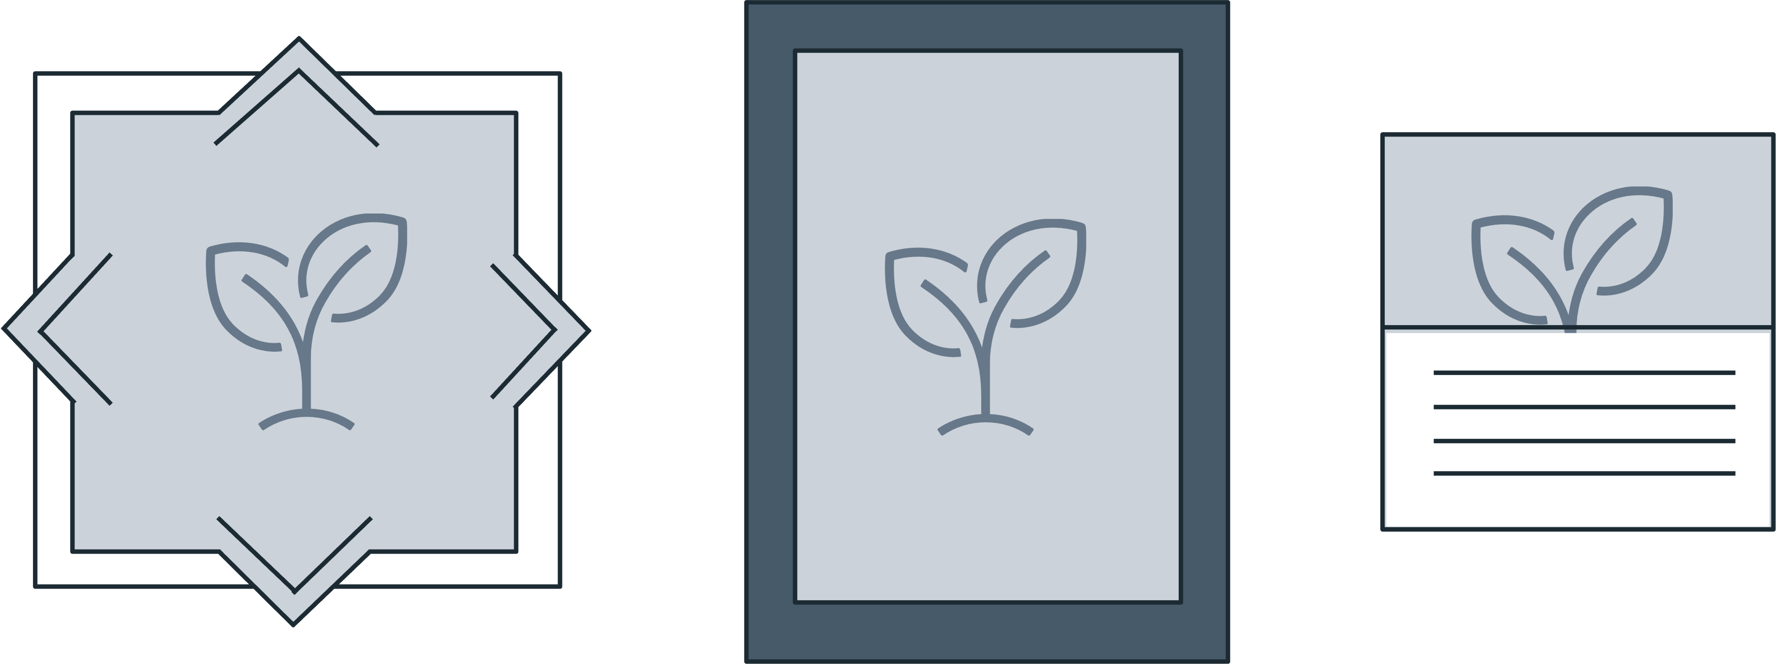

You can use box outlines or graphic elements to enhance or draw attention to specific elements of your design. The frame draws attention to the piece and directs the eye to the essential parts.

**Grid**

Think of a design grid to be the foundation of a house; it is a necessary first step in allowing you to build a functional and beautiful final product. It indicates to the builder or designer where certain elements should be placed, what should align with what and also provides a general outline.

Grids are important but often unseen components of almost any design. They are made up of a set number of rows and columns against which you can align your elements. Grids can help you keep your content organized, neat, legible and visually appealing. So, start with a grid that works for you and your design and work your way up from there.

**Direction**

The direction and movement of the eye across the page are important aspects of many designs; this is also referred to as "flow." How do your eyes cross the page? Do your readers know what to look for next? Is the path their eyes take logical?

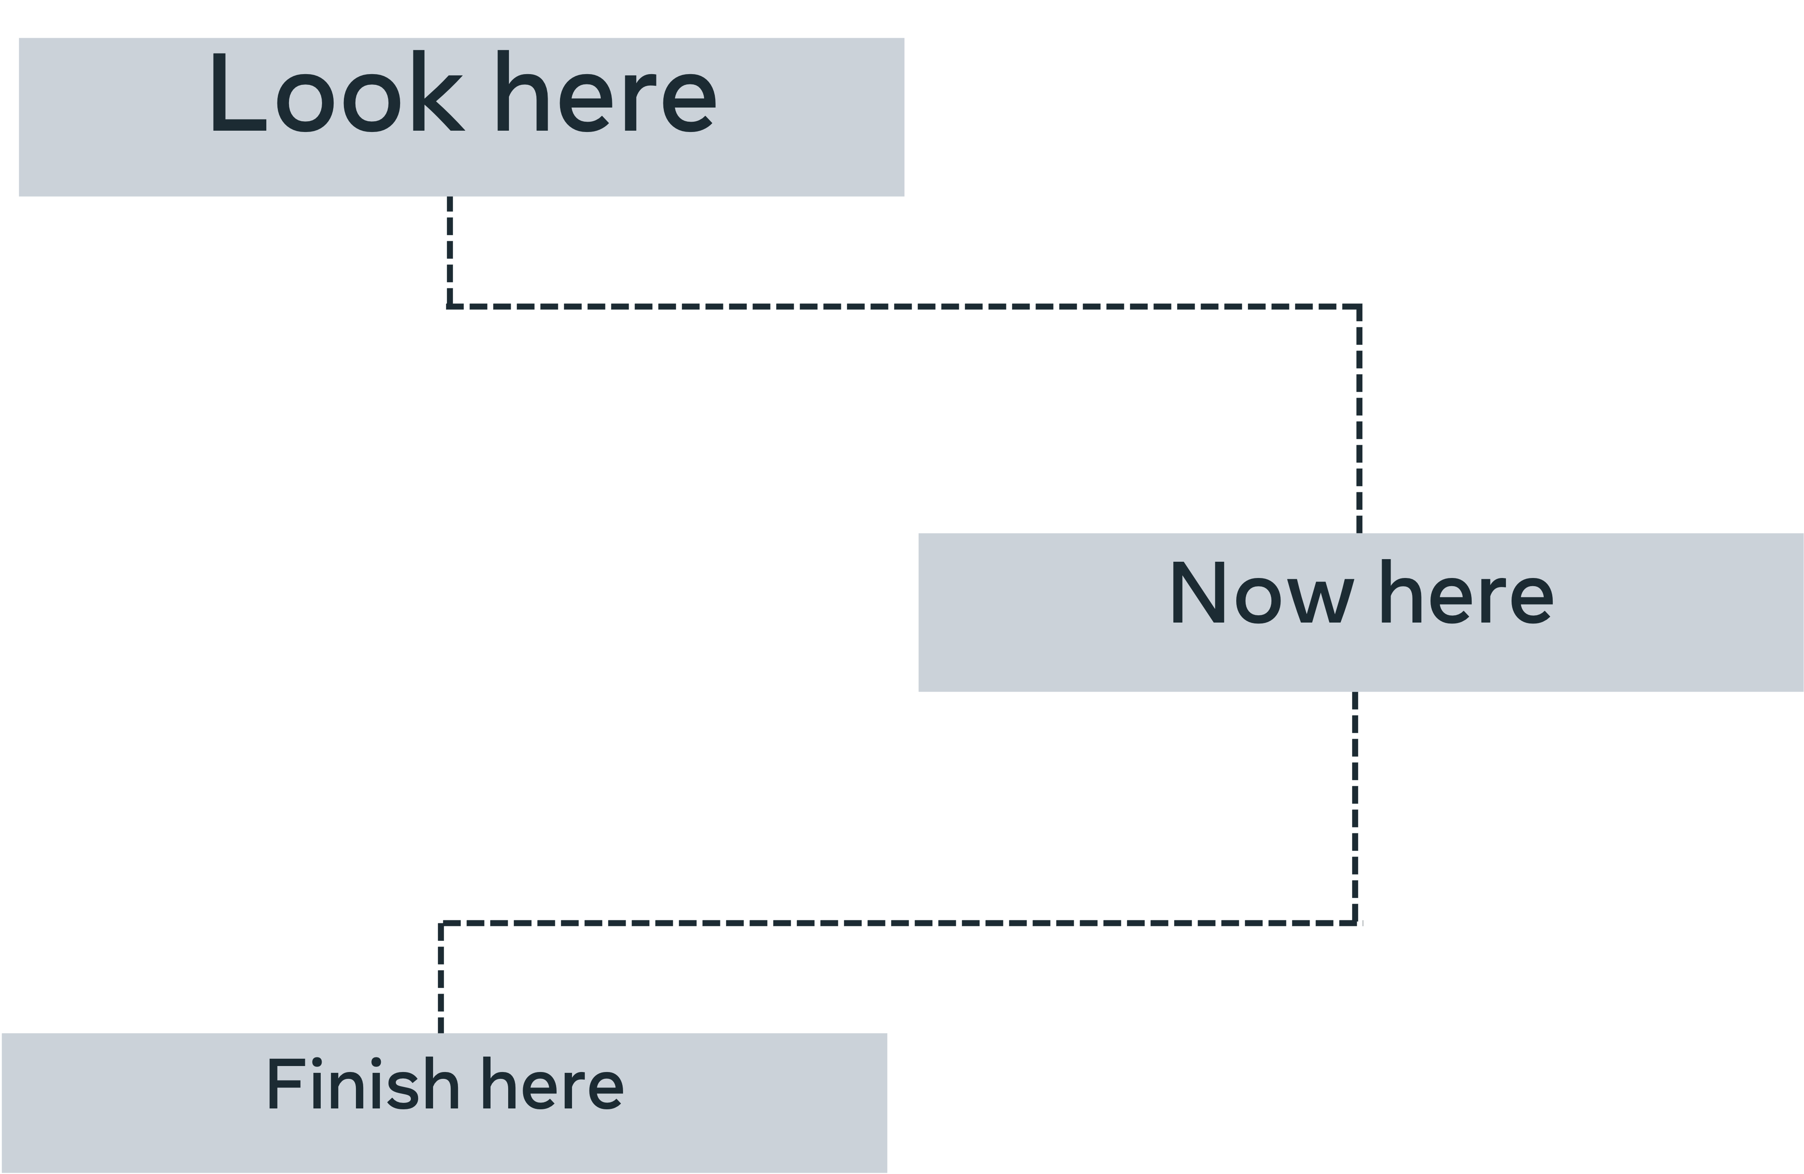

Several studies have been conducted to determine the precise nature of our eye movement habits and the patterns our eyes trace when viewing specific objects. Click the link below to explore the Nielsen Norman Group eye-tracking study, which tracked people's eyes while viewing web pages to determine their use patterns.

<https://www.nngroup.com/articles/f-shaped-pattern-reading-web-content-discovered/>

According to the research, a common pattern for the eye to follow is an "E" or "F." So, placing your top content to the left or along the top is perhaps the best way. A "Z" shape is another common pattern that the eye follows.

The general idea is that the eye naturally travels in a "sweeping" motion from the top left corner to the bottom right corner. This theory is best explained in depth by The Gutenberg Diagram. Click the link below to read this theory in detail.

<https://3.7designs.co/blog/2009/01/03/the-gutenburg-diagram-in-design/>

Rather than designing entirely around these patterns, try to adapt the flow and direction of your designs on a case-by-case basis. Just keep in mind that the eye is drawn to the top left corner of the page and works its way down.

**Rules**

This is a topic that is sure to spark heated debate and divide any room of designers, with one half proclaiming that there are no rules in design and the other claiming that there are many. Technically, they're both correct. As with any skill, there are things to learn, and these come with general guidelines. Make sure your type is legible, learn to kern (adjust the spacing between individual letters or characters), avoid using pixelated images and so on. These are the design foundations, the elements that help you create a basic design. However, as many argue, once you've learned these rules, it's time to break them. Both following and breaking the rules have their place in the world of design.

**Depth**

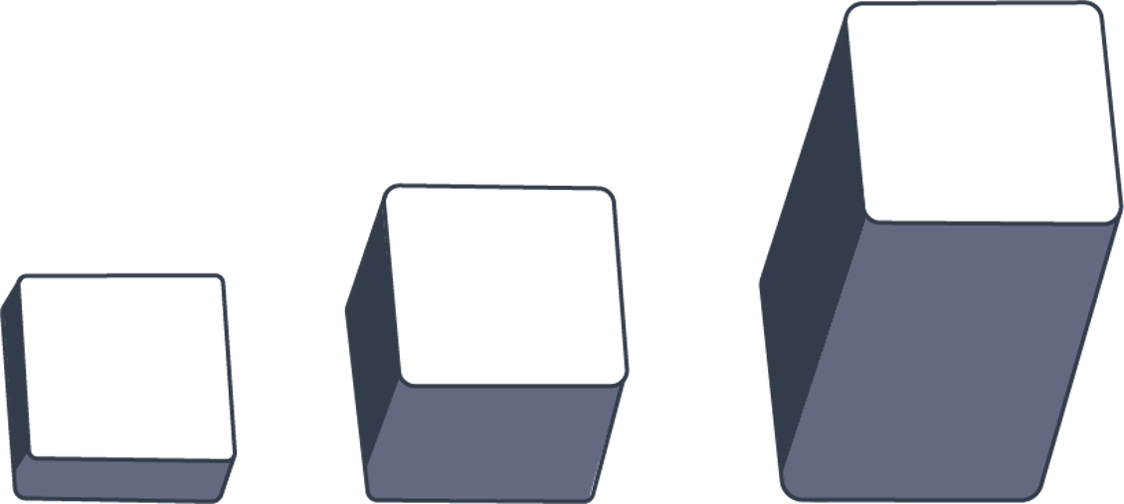

In the world of design, depth is an essential and exciting principle. You can create a sense of depth and the illusion that your design extends beyond the second dimension, even with the flattest of mediums. There are numerous techniques for communicating depth in your design; let's go over a few. First, there are shadows, which are probably the most well-known technique. Shadows are tricky because they aren't always linearly shaped, as they can stretch, bend, warp and skew. So, observing real-world shadows and seeing how the light hits various objects at different points is a good technique for exploring shadow usage.

Overlapping certain elements is another technique. This reduces the flat appearance of the design and makes it appear more layered, with different levels and tiers. Another technique is to experiment with perspective, which often gives elements a "3-dimensional or 3D effect". You can give the illusion of raising certain elements off the page by adjusting their perspective, creating instant depth. On the other end of the spectrum, you can reduce the amount of depth in your design. This is a recent popular style, also known as 'flat design.'

**Composition**

Composition is an excellent place to end because it connects all the other principles discussed earlier on.

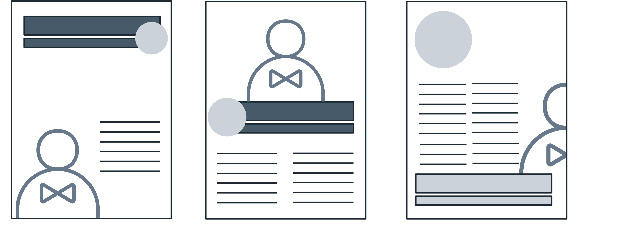

"Composition" refers to the overall arrangement of elements in your design, which sounds a little boring when explained that way, but it's one of the more enjoyable aspects of design. This is where you can experiment and make a good design look even better.

**Final thoughts**

The application of these principles will assist you in designing with purpose by providing function to every element in a composition. Communicating a clear message is not only about the message itself but also about how you carry it out in order to deliver it clearly.

Consider these principles and how they are applied the next time you look at a design composition. You'll be able to decode even the most complex designs and understand what works and what doesn't.